Genetics Australia’s NSW RED OFC 2019 Results
2 year old Class

1 Mayfield Gentle Rose (Pictured) Gentleman Timbs
2 Creighton Park Elizabeth 2569 Blush Squard Parker
3 Fairy Vale 999 Melissa VR Harvard Blasche
4 Beaulands Fritz Scarlet VR Fritz Graham
5 Moyola Marlene 2 VR Cigar Gallagher
6 Beaulands Foske Lady7 V Foske Graham
7 Elmshade Berkley Desire Bendig Berkley Fahey
8 Moyola Daphne 9 VR Fritz Gallagher
9 Farrer Dew Drop 210 Farrer Ag
10 Creighton Park 2607 Parker

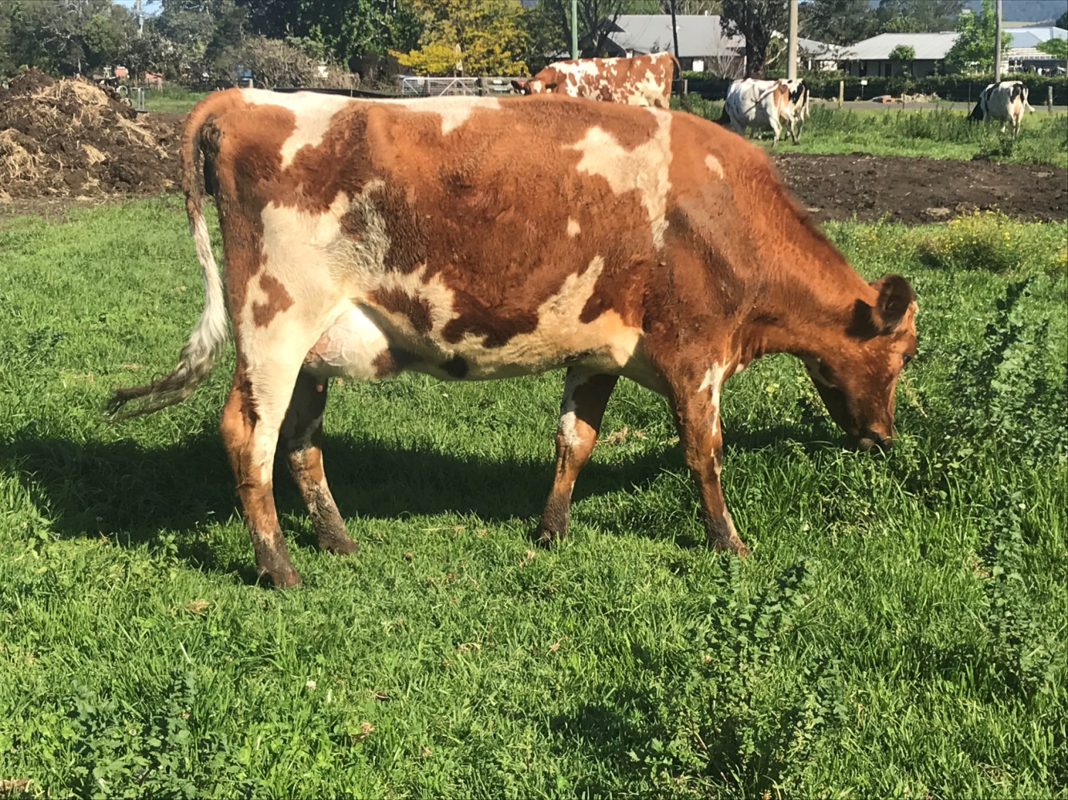

3 year old Class

1 Hillcrest Jumper Lorette (Pictured) Jumper Crawford
2 Coolea Burdette Delicious Burdette Crawford
3 Mayfield Farm Prim Rose Plaine Prime Timbs
4 Creighton Park Flossie 2513 Blushs Savard Parker
5 Regal Park Posh Spice Plaine Vicking Mayo
6 5139 Beaulands Dan Miller
7 Eagle Park Maxima Heather 4169 Maxima Shierlaw
8 Fairy Vale 924 Nellie V Foske Blasche
9 Fairy Vale 915 Patty VR Cigar Blasche
10 Moyola Colleen 33 V Foske Gallagher

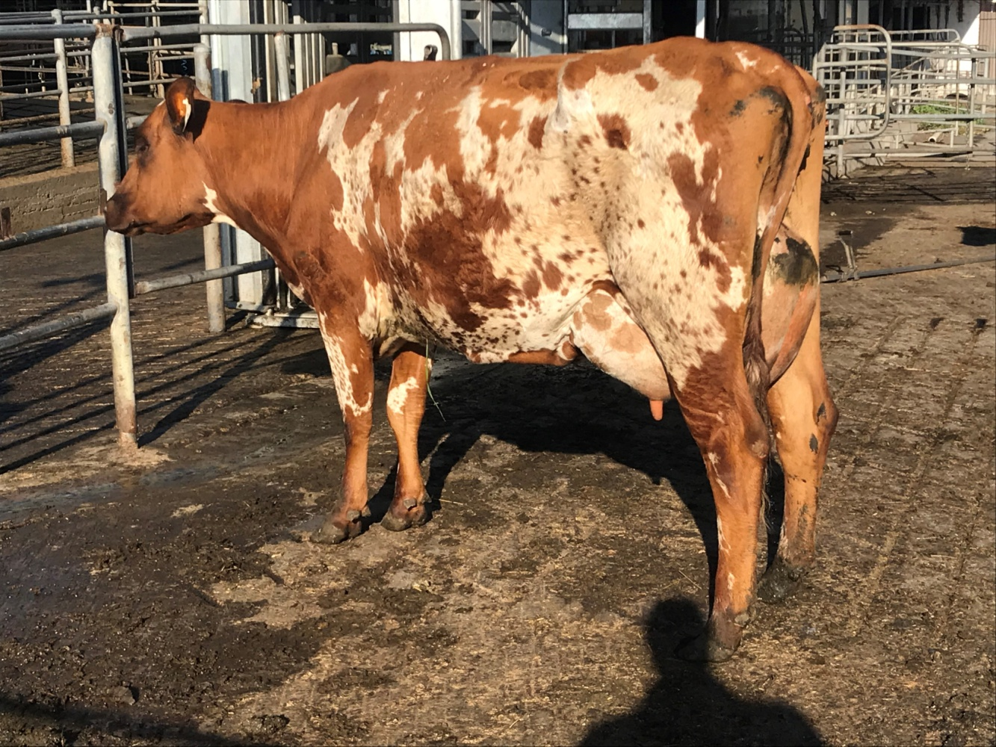

4 Year Old Class

1 Coolea Predator Zerene (Pictured) Predator Crawford
2 Eagle Park Pingerly Duchess Pingerley Shierlaw
3 Flame Canary 3781 VR Flame Downes
4 Beaulands Foske Clarabel Foske Graham
5 Beaulands Foske Primula Foske Graham
6 Regal Park Jumper Rose Jumper Mayo
7 Creighton Park Faith 2420 CP Monty Parker
8 Eagle Park Maxima Honeymoon Maxima Shierlaw
9 Eagle Park Manu Matilda Eagle Park Manu Shierlaw
10 Creighton Park Quiver 2434 Elmo Parker

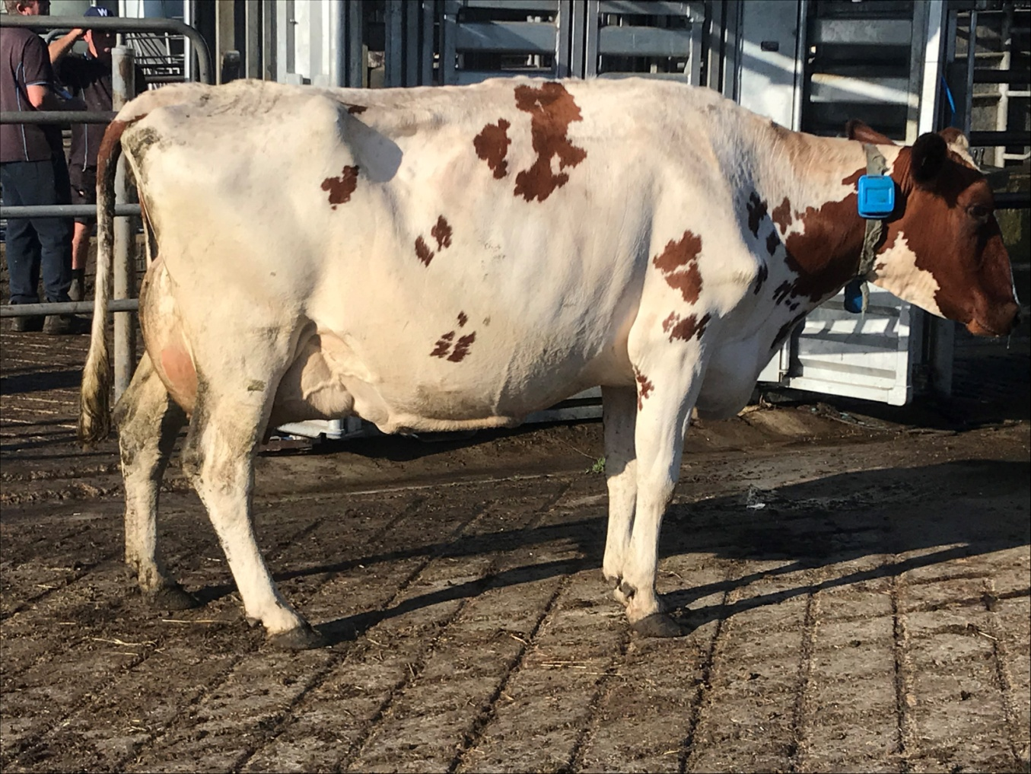

5 year old Class

1 Sirikit 3521 (Pictured) VR Cigar Downes
2 Fairy Vale 807 Penny FV Terry Blasche
3 Moyola Honey 40 MH Toby Gallagher
4 Fairy Vale 770 Betsy VR Cigar Blasche
5 Princess 3540 Beaulands Fox Downes
6 Creighton Park Elizabeth 2355 Pingerly Parker
7 Beaulands BFoske Rebecca BFoske Graham
8 Mayfield Farm Titan Secily Titan Timbs
9 Moyola Dianne 63 Landover Gallagher
10 Creighton Park Roselyn 2334 Charlie Parker

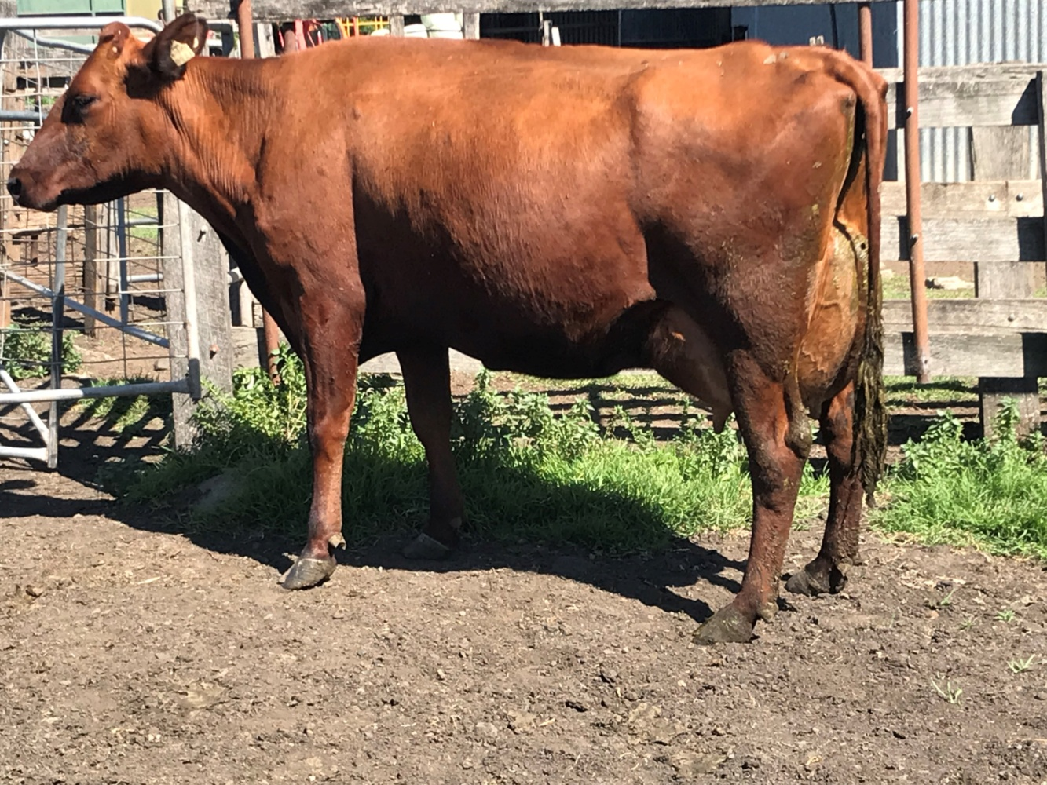

Mature Class

1 Eagle Park Prophet Jean 3944(Pictured) Prides Prophet Shierlaw
2 Creighton Park Duchess 2152 KW Charlie Parker
3 Euroma Meeson Emily Meeson Tomkins
4 Creighton Park 2131 Parker
5 Facet Dalene V Facet Tomkins
6 Beaulands Klens Hazel Klens Graham
7 Beaulands Foske Birdie 4 Foske Graham
8 Jondene Dainty 1008 Jondene Ford Farrer Ag
9 Mia 3516 Waikato Farm Lion Coulthart
10 Gregleigh Talented Nell Talented Farrer Ag

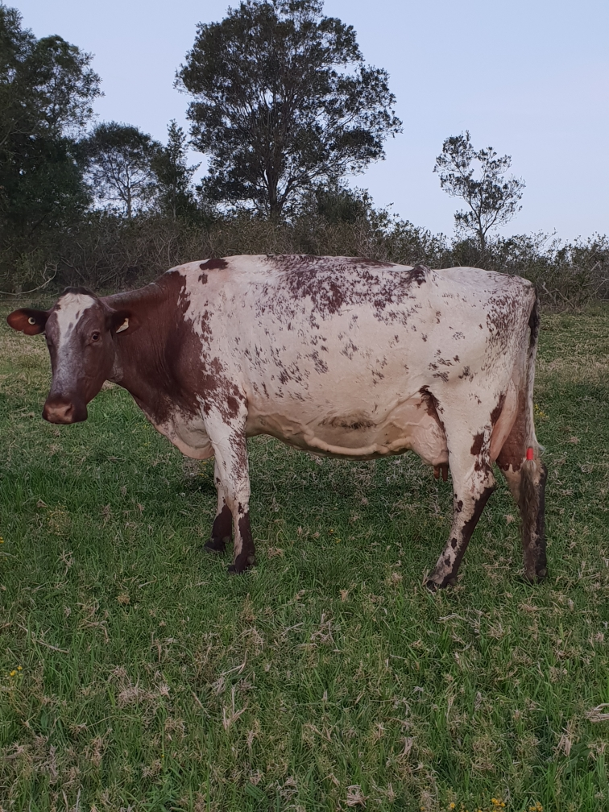

Overall Champion: Coolea Predator Zerene

Judge: Brayden Evert

