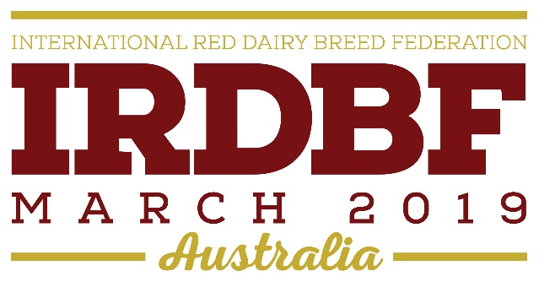

AUSTRALIAN RED DAIRY BREED REGISTER INC
IRDBF 2019 YOUTH SCHOLARSHIPS

BACKGROUND
The Australian Red Dairy Breed Register Inc (ARDB) is hosting a conference and tour titled “Bringing Red Breeds Together” on behalf of International Red Dairy Breeds Federation. The event runs from 22nd March to 29th March 2019. ARDB is delighted to offer three (3) scholarships to successful applicants to attend the event free of registration fees. Full details of the event are available at www.irdbf2019.com.au

The scholarships are an initiative of the Australian Red Dairy Breed for the purpose of developing and enhancing young farmers in their understanding and participation in Red Dairy breeds.

The scholarships provide financial assistance to the value of $880 per awarded place to cover registration fees for the IRDBF 2019 Conference in Australia. (Note: Travel to and from the conference, and accommodation during the conference is not covered in this scholarship).

ELIGIBILITY
• Applicants must be aged between 18-35years old.
• Applicants must be engaged in farming as an owner, manager, sharefarmer, or employee in a Red Dairy farming enterprise/ or crossbreeding with reds.
• Applicants must have the ability to take the time off work to attend the conference.

GENERAL CONDITIONS
• Applicants are required to provide all details as requested on the application form.
• Two referees are to be nominated by each applicant.
• All information provided by the applicants and their nominated referees will be treated by the panel as confidential.
• The Australian Red Dairy Breeds and supporting sponsors shall not be liable for any expenses incurred through illness or accident.
• On completion of the project the successful applicant/s will be expected to share their learning with the Australian Red Dairy Breed organisation. This will require a short written report on the value of the IRDBF Conference to be completed within 6 weeks of attending.
• The decision of the selection panel shall be final and no appeal by unsuccessful candidates entered in to.
• Applications must be received by 30th November 2018.
• The successful applicant/s will be contacted personally and in writing. Details of the successful applicant/s will be advertised on the Aussie Reds website www.aussiereds.com.au and the conference website www.irdbf2019.com.au

APPLICATION GUIDELINES.
• Application form to be completed by the applicants.
• Application to be typed or computer generated.
• Applicants must be Australian Citizens.
• Application must not exceed one (1) page.
• Application must be submitted by email to info@aussiereds.com.au
• Application must be received by midnight on day of advertised closing date, 30th November 2018.
• The successful applicant/s will be responsible for his/her own transport cost and all expenses associated with the conference accommodation.
• All medical and travel insurance costs are to be met by the successful applicant/s along with medical requirements prior to travel.
• The award recipient/s are able to be accompanied by a partner, chaperone or family member at his/ her own expense.
• The award recipient/s are ambassadors of the Australian Red Dairy Breed and must at all times conduct themselves in a manner befitting of his/her role and position.

Continued on next page.

IRDBF 2019 SCHOLARSHIP APPLICATION FORM (1 page maximum)

Name:

Age:

Address:

Email:

Mobile:

Referee 1 name:
Referee 1 mobile:

Referee 2 name:
Referee 2 mobile:

1. Describe your experience working in the Dairy Industry.

2. Why would you like to attend the IRDBF 2019 Conference?

3. What involvement do you have with Australian Red Cattle?

